Jenkins Assignment 2 Using Pipeline
- lauch instance install java ,git, wget tomcat inside /mnt/server then give permission then setup Jenkins goto webapp wget Jenkins then setup
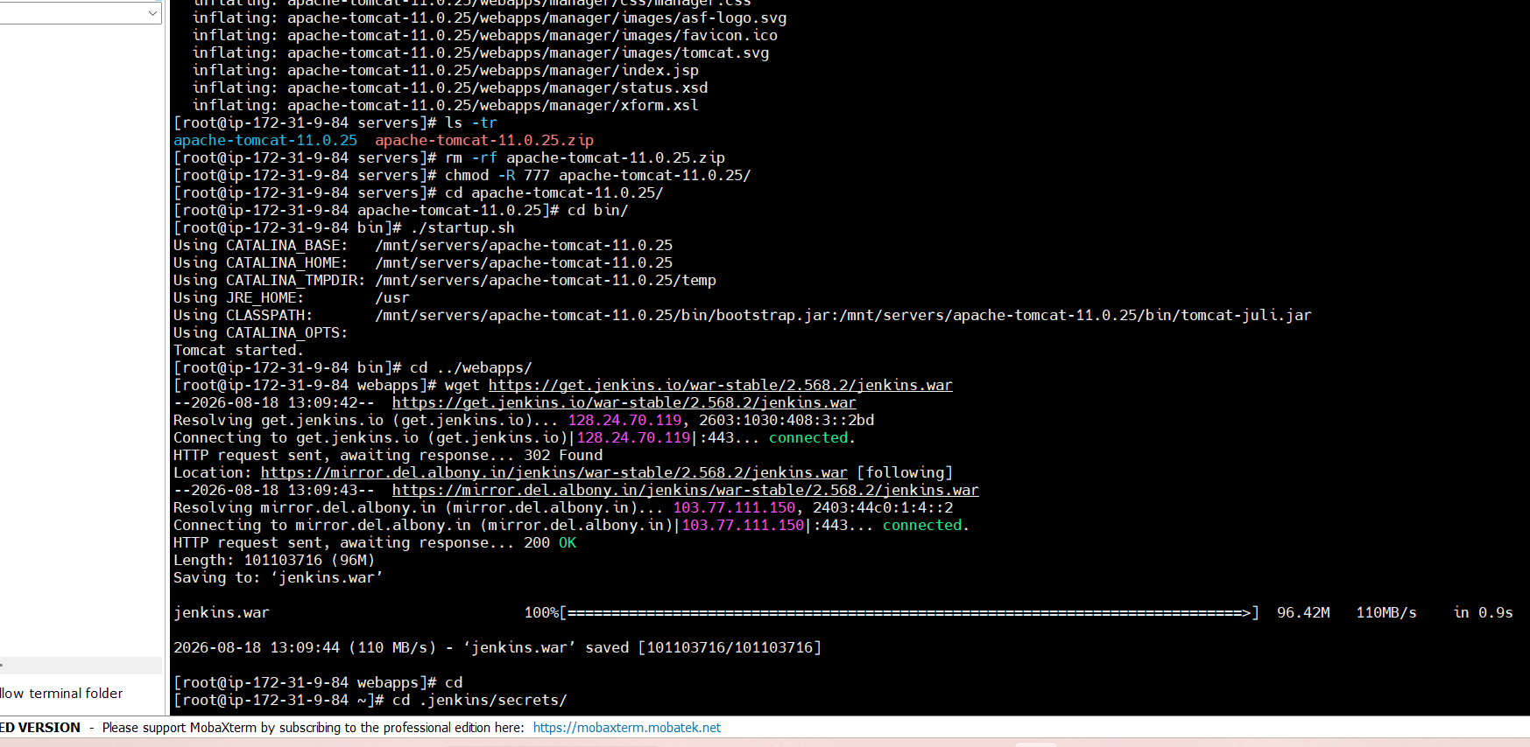
step 2 – open git take url of repository where index.html file is present then goto Jenkins dash board and create new item and use pipeline job
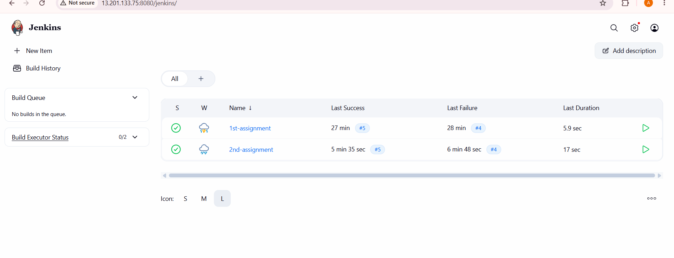
Step 3 – add pipeline code/script inside this job
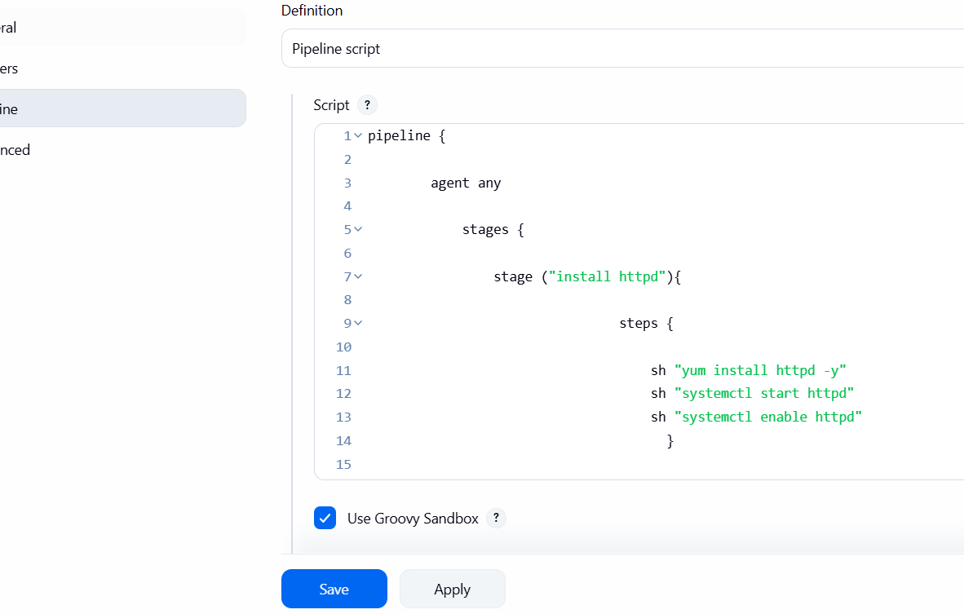
Add this pipeline code
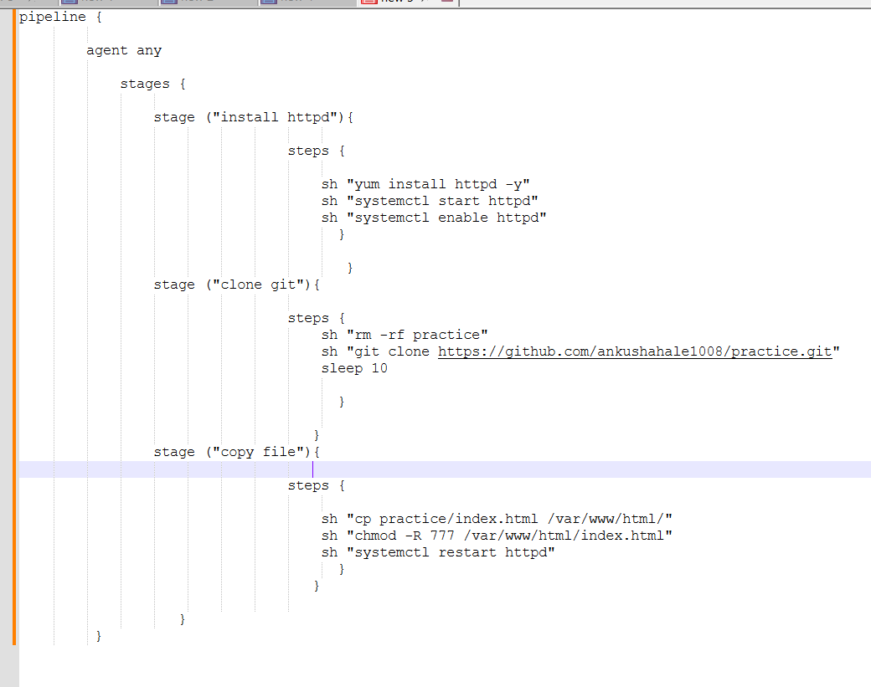
Step 4 – goto stages and check
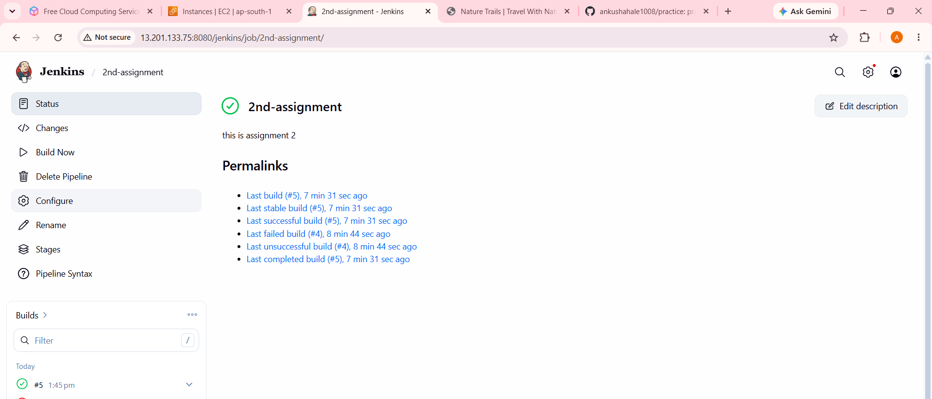
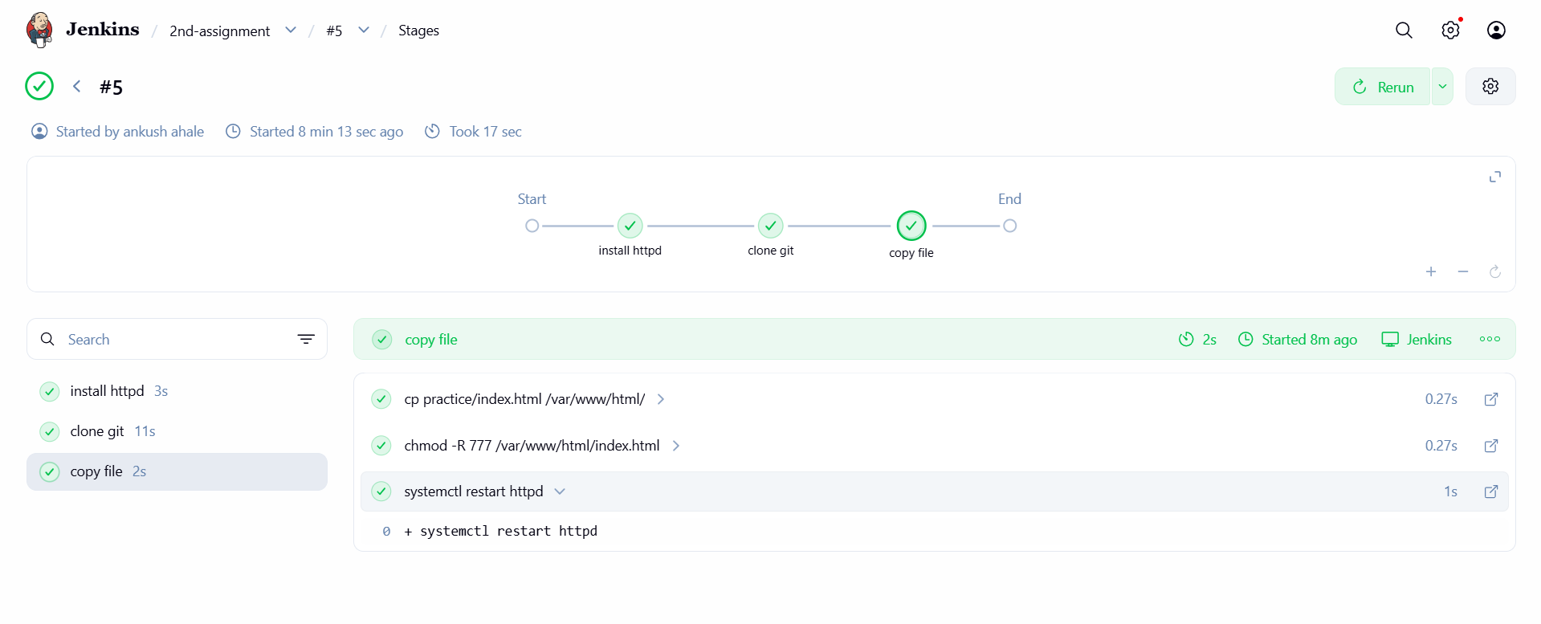
Step 5 – check on url like http://publicIP

Done Successfully.

